CRYPTO (SESSION 4)
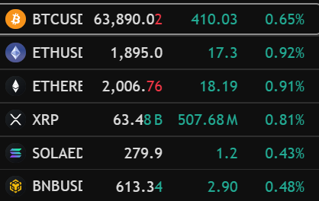

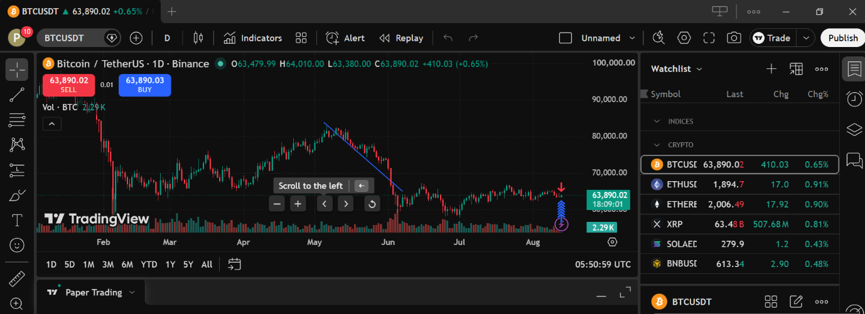
BITCOIN USD
ETHEREUM
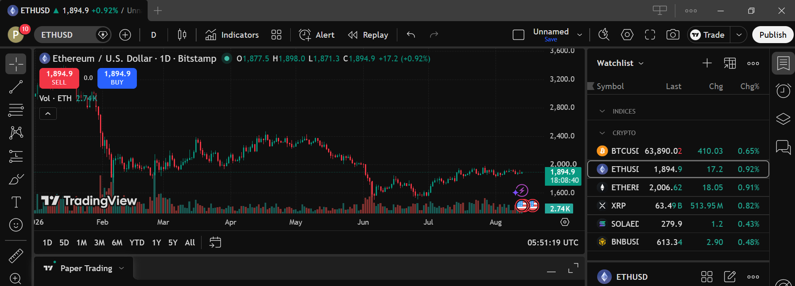

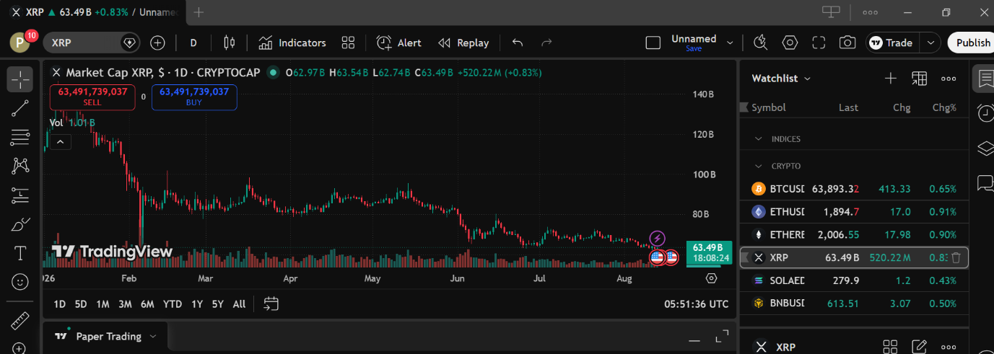
XRP

SOLANA
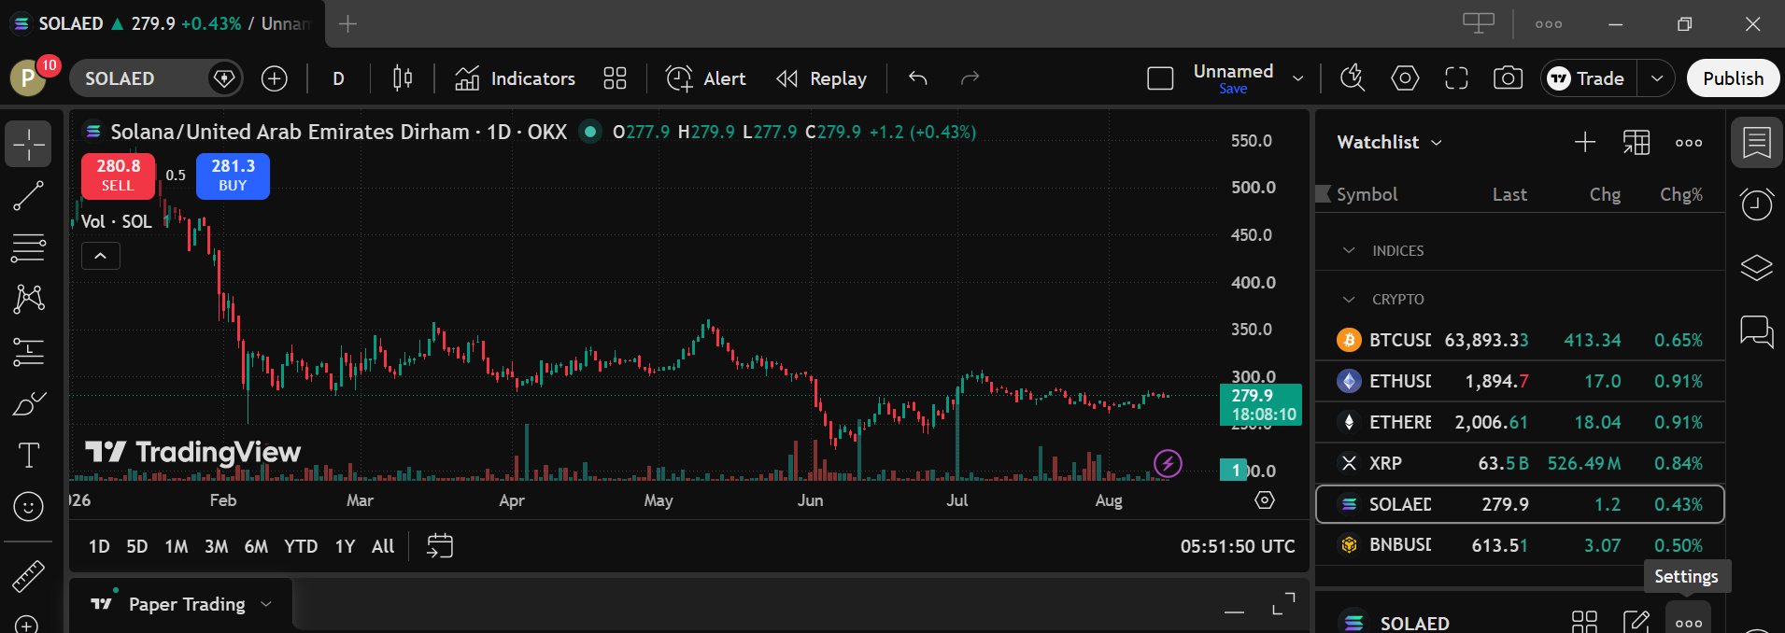
BINANCE
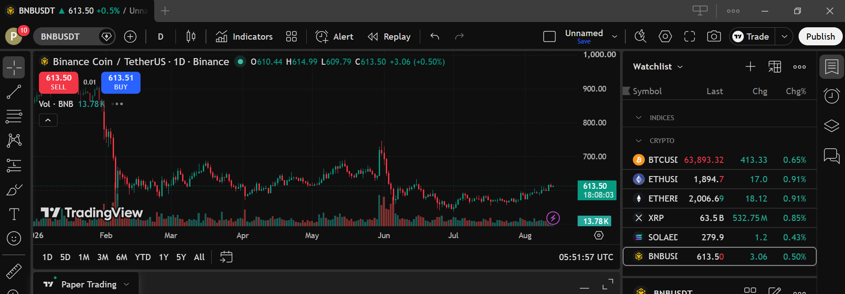

SESSION 5

SCREENSHOT OF EXECUTED BUY ORDER / OPEN POSITION
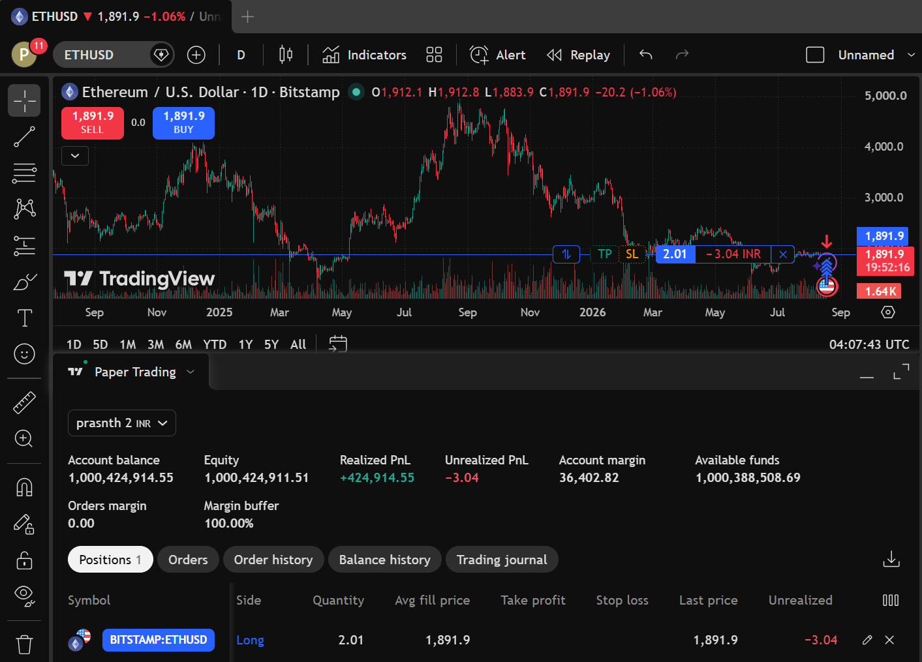

FIRST TRADE RECORD
TRADE DETAILS
PARTICULAR | DETAILS
ASSET NAME | ETHEREUM
SYMBOL | ETHUSD
TRADE TYPE | BUY
QUANTITY PURCHASES | 2.01
AVERAGE FILL PRICE | 1,891.9
TRADE VALUE | 364,03.25 INR
DATE & TIME OF TRADE | 18/08/2026  (09:32 AM)

POSITION OBSERVATION
PARTICULARS | VALUE
LAST PRICE | 1,895.0
TRADE VALUE | 364,031.25INR
UNREALIZED P&L | +539.57INR

SESSION 6

Profit/loss Observation Table
Particulars | Details
Asset Name | Ethereum
Symbol | ETHUSD
Quantity Purchased | 2.01
Purchase Date & Time | 18/08/2026 (9:31 Am)
Average Fill Price (Purchase Price) | 1,891.9
Exit Date & Time | 2026-08-18 10:11:15
Exit Price (Selling Price) | 1,894.7
Final Profit/Loss (Realized P&L) | +539.57INR
Trade Outcome (Profit/Loss) | Profit

